Lend A Helping Hand at Asan Shelter

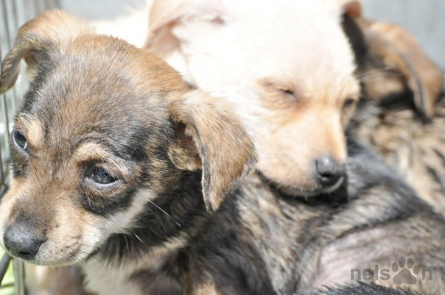

Walking the dogs:

The most common task volunteers perform at Asan is walking the plethora of dogs. And, trust me: They are usually overjoyed at the prospect of stretching their furry legs. So, what is the typical procedure when walking an Asan pup? Firstly, always be sure to check that the dog isn’t on heartworm medication. If a pup is going through heartworm treatment, he/she can only have a very minimal level of exertion. Next, respect the doggy’s body language! Sometimes, the dogs just want to cuddle, or they just want some company. Some have never even been on a walk before! Only walk one dog at a time to avoid any unnecessary escapes. Always keep a respectful distance with other dog walkers. Some dogs socialize with other pups quite well, and some don’t. Just beware. Please never text on your cell phone when walking your doggy. You have the dog’s undivided attention, so return the favour.

Now, what is the procedure?

Bigger dogs are spread out in pens on a hill, and some of the smaller dogs are kept in separate cages at the bottom of the hill. If you’re walking a dog from a pen with many pups, DON’T go alone. Ask another volunteer to accompany you. If a dog escapes, shout “LOSE DOG” so other volunteers know that a dog has escaped. Be sure to bring a leash and collar with you (as not all of the pups wear collars). Leashes are usually hung on the door of the shelter complex at the bottom of the hill, and collars are in bins beside the door. Only walk dogs YOU feel comfortable walking.

Cleaning the Cages:

With a surplus of 150 dogs, I’m sure you can imagine how hard it is to keep cages clean. This is a pretty self directed task. If you see a really dirty cage, then clean it! Cleaning supplies can be hard to come by, but check under the sink in the shelter complex at the bottom of the hill, or in the bathroom located in the hut beside the shelter complex. Even something as simple as scooping old poop from a cage can make a world of difference to improve a pup’s living conditions. Do what you see when it needs doing. There’s also a small cat house at the bottom of the hill. Quite often, their litter boxes could use cleaning and replenishing with fresh litter.

Top up Water Dishes:

If you notice that a dog doesn’t have water, then fill up his/her water dish! There are watering cans all around the shelter, several hoses and a sink in the shelter complex. There are so many dogs, and so few hands. If you think a doggy needs fresh water, then change it.

Aggressive Dogs:

If you’re unsure about walking a dog, then ask first. Pay special attention to body language. There are a few bigger dogs at the shelter who don’t get walked because they’re not good with other dogs. Just be careful, and use common sense. When in doubt, ASK!

This isn’t a Fashion Show:

So, here’s the score: You’re going to get muddy, dirty, and drooled on by lovable pups. Wear running shoes, or equally comfortable shoes, that can get DIRTY. Sandals, or open toed shoes, are not a good idea. Rubber boots are great in monsoon season. Seriously, when that big hill gets muddy, you want to be wearing proper footwear. Wear old clothes that you don’t care about getting dirty. Trust me: They will smell like dog forevermore. Also, it’s a good idea to bring an extra pair of fresh clothes to change into for the long subway ride home.

What to Bring:

- Hand Sanitizer
- Lunch
- Doggy Treats
- Comfortable Shoes
- A Change of Clothes
- Gloves
- Water
THANK YOU FOR GIVING FOR TIME AND, MOST IMPORTANTLY, YOUR LOVE!
THE DOGS SAY “WOOF WOOF” (DOGSPEAK FOR THANKS!)

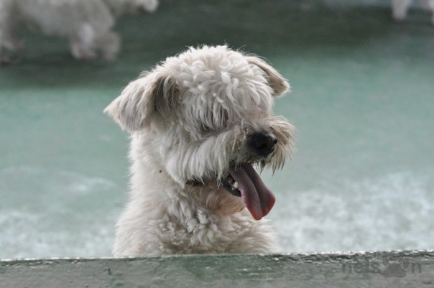
Thanks to Hamish Nelson for Photographs.

